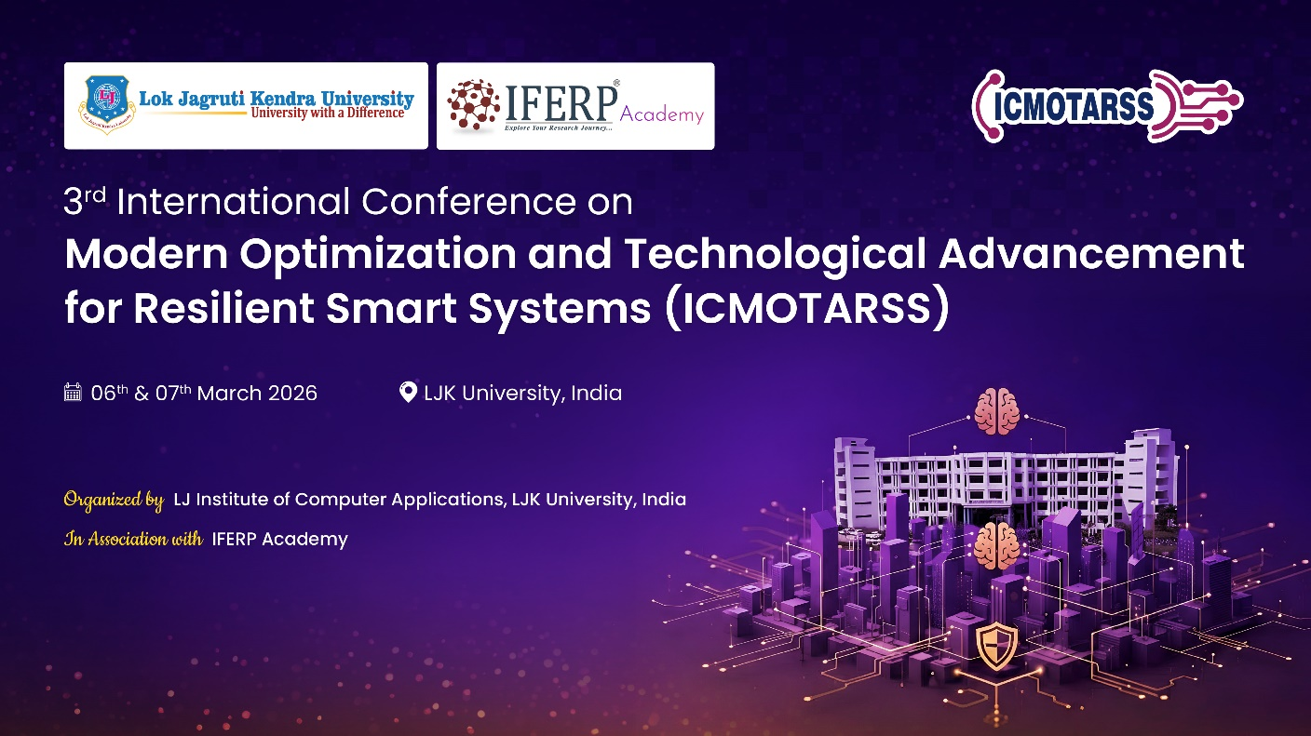
3rd International Conference on Modern Optimization and Technological Advancement for Resilient Smart Systems (ICMOTARSS-2026)
Organized by LJ Institute of Computer Applications, LJK University
In Association with IFERP Academy
Post Conference Report
ICMOTARSS-2026, Contributed to Following SDGs
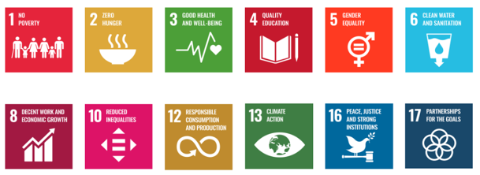

Table of Contents
1. Conference Summary
1.1 Conference Overview
1.2 Conference Theme
1.3 Objectives & Scope of the Conference
2. Guest of Honor, Keynote Speakers, Workshop Speakers, & Session
Chairs

3. Inauguration Events – Day 1
3.1 Welcome Address - Dr. Alok Manke
3.2 Lamp Lighting Ceremony
Steering Committee Member Dr. Siddarth Singh Bist
Steering Committee Chairperson Prof. Rakesh Basant
3.4 Saraswathi Vandana
3.5 Souvenir Book Lauch
3.6 Keynote Address - Dr. Hitesh Shrimali
3.7 Presidential Address - Prof. Dinesh Awasthi
3.8 Vote of Thanks

4. Inauguration Events – Day 2
4.1 Welcome Address
4.2 Address by Programme Coordinator
4.3 Keynote Address - Dr. Dipankar Deb
4.4 Keynote Speech - Prof. Ts. Dr. Norita Md Norwawi
4.5 Keynote Speech - Dr. Shobhit K. Patel
4.6 Announcement

5. National Anthem

6. Group Photo

7. Networking Break

8. A Panel Discussion on
- Voice AI as the Next Frontier of Human-Machine Interaction – Opportunities, Challenges, and Real-World Applications

9. Lunch Break

10. Technical Sessions – Session Chairs (Physical and virtual mode)
Day 1
Track | Session Chair
1.1 | Dr. Digvijay, Dr. Anjum Parveen Nazir Qureshi
1.2 | Dr. Hardik Soni,Dr. Koushick Venkatesh
1.3 | Dr. Sandeep Vasant, Dr. Sc. Dedi Darwis
1.4 | Dr. Priyank Nahar, Dr. Kalayani Patel
1.5 | Dr. Disha Parekh, Dr. Goh Wei Wei
1.6 | Dr. Shobhit Patel, Dr. Ryan Randy
1.7 | Dr. Vinod Desai, Dr. Nikita Jain
1.8 | Dr. Arpit Jain, Dr. Sharanya
1.9 | Dr. Vihal Polara, DR. POOJA M. BHATT
1.10 | Dr. Sheetal Solanki, Rodrigo Salimaco Jr.
1.11 | Dr. Jay Patel, Dr.sundaresan
1.12 | Dr. Prashant Pitaliya, Dr. Khyati Rami
1.13 | Dr. Ajay Upadhay , Dr. Meena Chavan
1.14 | Dr. Jignesh Chouhan, Dr. Mehul Patel, Dr. Meghna Patel

Day 2
Track | Session Chairs
2.1 | Dr. Vishal Polara, Dr.Agung triayudi
2.2 | Dr. Angira Patel, Dr.Deenadayalan T
2.3 | Dr. Rajiv Mathur, Dr. Priyank Nahar, Dr. K.Sasikala
2.4 | Dr. Mukta Agrwal, Dr Humaira Ashraf, Dr. Amit Bindaj Karpurapu

11. Keynote Speeches
9.1 Keynote Speaker - Dr. Hitesh Shrimali (Day-1)
9.2 Keynote Speaker - Prof. (Dr.) Shobhit K. Patel (Day-2)
9.3 Keynote Speaker - Dr. Dipankar Deb (Day-2)
9.4 Keynote Speaker - Prof. Ts. Dr. Norita Md Norwawi (Day-2)

12. Poster presentation - Technical Tracks – Day 2

13. Valedictory Function

14. Vote of Thanks

15. Conference Glimpses

16. General Comments & Feedback

17. Challenges
Conference Summary
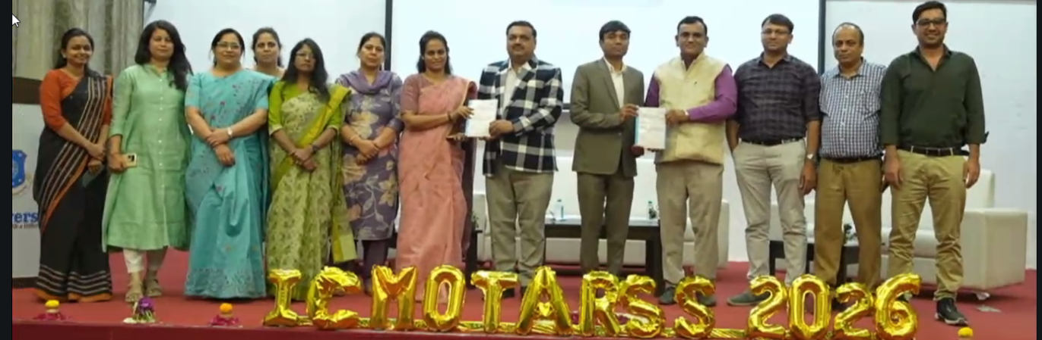
Conference Name: 3rd International Conference on Modern Optimization and Technological Advancement for Resilient Smart Systems (ICMOTARSS-2026)
Date: 06th & 07th March 2026
Venue: Ahmedabad, India
Conference Theme: Modern Optimization and Technological Advancement for Resilient Smart Systems
Organized By: LJ Institute of Computer Application
In Association with: IFERP Academy.

No. of Organizing Committee Members: 48
No. of Editors/Reviewers:
No. of Speakers: 4
No. of Abstracts Received: 250
No. of Participants Registered: 150
No. of Physical Attendees: 35
  - Conference Overview
The LJ Institute of Computer Application and IFERP Academy will host the 3rd International Conference on Modern Optimization and Technological Advancement for Resilient Smart Systems (ICMOTARSS-2026). This global event aims to bring together leading researchers, academicians, industry experts, innovators, and students to exchange breakthrough ideas, cutting-edge research, and practical insights. With multidisciplinary tracks spanning Artificial Intelligence, Optimization Techniques, Data Science, Internet of Things (IoT), Cybersecurity, Smart Engineering Solutions, Cognitive Computing, and emerging areas in resilient and intelligent systems, the conference seeks to foster knowledge-sharing and inspire advancements in future-ready technologies. ICMOTARSS-2026 will feature keynote addresses, invited expert lectures, panel discussions, and peer-reviewed paper presentations delivered by esteemed global professionals.
Aligned with LJK University’s vision of fostering high-quality, inclusive, and industry-aligned education, ICMOTARSS-2026 serves as a platform to promote interdisciplinary collaboration, innovation, and impactful research. Leveraging the university’s strong academic ecosystem—supported by modern infrastructure, research-driven pedagogy, incubation centers, and established industry partnerships—the conference aims to accelerate transformative research and contribute to the development of secure, resilient, and intelligent technological ecosystems.
Through meaningful discussions, research engagement, and collaborative opportunities, this event aspires to empower participants to address contemporary technological challenges and shape the future of smart, sustainable, and resilient systems.

  - Conference Theme
The conference theme focuses on integrating sustainability and circular economy principles into business and management practices to advance the UN Sustainable Development Goals (SDGs). It emphasizes the role of organizations in driving social equity, environmental stewardship, and long-term competitiveness. The theme highlights circular practices like waste reduction, resource regeneration, and product longevity. It also addresses challenges faced by businesses, such as balancing priorities and measuring impact. With growing demands for transparency and ESG accountability, the conference promotes collaborative solutions and actionable insights to accelerate SDG progress
  - Objectives & Scope of the Conference
The primary objective of the International Conference on Emerging Trends in Management Practices (ICETMP-2026) is to foster meaningful dialogue and innovation in integrating sustainability into modern business strategies. It serves as a dynamic platform for scholars, industry leaders, policymakers, and students to exchange knowledge, share emerging trends, and explore practical frameworks for sustainable management. By bridging academia and industry, the conference encourages collaborative research, policy development, and the creation of impactful solutions addressing global sustainability challenges. It also seeks to identify research gaps, inspire future scholarship, and promote lasting professional networks that drive responsible and resilient business practices worldwide.

Guest of Honours
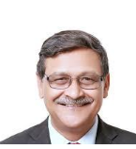
Director
Indian Institute of Management (IIMA)
Ahmedabad, India

Keynote speakers
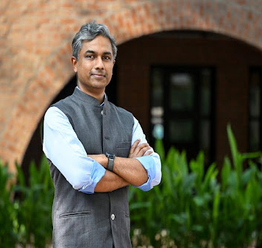 | 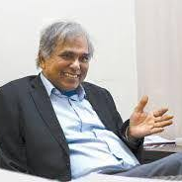 | 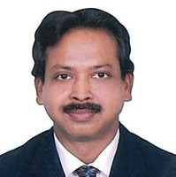
Prof. Anish Sugathan  Faculty, Strategy Area, Indian Institute of Management Ahmedabad (IIMA)  Co-Chairperson, Duggal ESG Centre for Research and Innovation, IIMA | Prof. Amitabh Kundu  Professor Emeritus, LJK University  Visiting Professor, Maulana Azad National Urdu University | Dr. Narottam Sahoo  Advisor,  GUJCOST.
Panel Discussion
Attaining SDGs in Asian Countries: Role of Business Practices, Policy Environment and Challenges
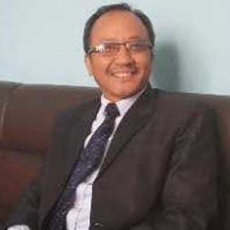 | 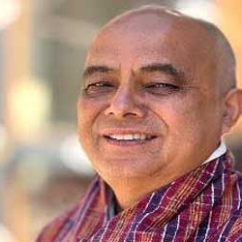 | 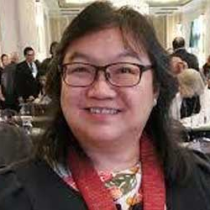
Prof. Govinda Tamang  Director, School of Management  Tribhuvan University  Nepal | Prof. Jit Tshering  Professor  Centre for Leadership Development  Royal Institute of Management  Thimphu  Bhutan | Prof. Au Yong Hui Nee  Dean,  Faculty of Business and Finance  Universiti Tunku Abdul Rahman,  Malaysia

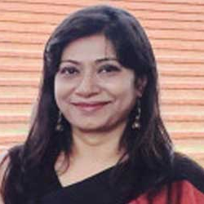 |  | 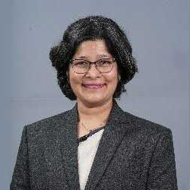
Prof. Ireen Akhter  Professor  Institute of Business Studies  Jahangirnagar University, Dhaka  Bangladesh | Dr. Achinthya Koswatta  Sr. Lecturer  Department of Social Studies  The Open University of Sri Lanka  Sri Lanka | Dr. Neha Shah  Associate Professor  LJK University  Ahmedabad  India
Panel Discussion
How High-Impact Sectors Measure, Govern, and Deliver ESG Outcomes
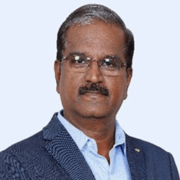 | 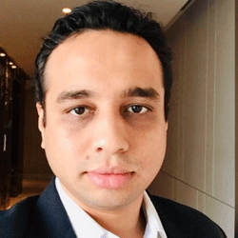
R.S.Sankarasubramanian,  Vice President – ESG  Torrent Group,  Ahmedabad, India | Ankur Dosi,  Director with PwC.  Ahmedabad, India
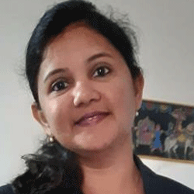 | 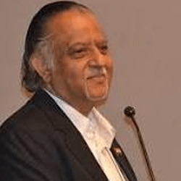
Archana Thosar,  Co-founder and Director  Green Maneuver Industries  Ahmedabad, India | Dr. Sunil R Parekh  Member - Board of Management, LJKU University.  Chairman CERC,  Advisor Zydus Lifesciences Group

Session Chair
Day -1
Session Number | Session Chair - 1 | Session Chair - 2
1 | Dr. Indra Meghrajani | Dr. Bijal Mehta
2 | Dr. Anu Gupta | Dr. Pragya Sharma
3 | Dr. Ketan Shah | Dr. Himani Baxi
4 | Dr. Silvia Georgieva | Prof. Chandramauli Pathak
5 | Prof G R Sinha | Prof. Margie Parikh
6 | Dr. Shubhra Anand | Dr. Neha Puri
7 | Dr. Ankita Srivastva | Dr Surabhi singh
8 | Dr Abha Kalaiya | Dr. Sunita Bhandari & Dr. M M Bagali
9 | Dr. Yogesh Jain | Dr. Sarika Srivastava
10 | Dr. Ruchi Khandelwal | Dr Ranjan Upadhyaya
11 | Prof. Thomas Muthucattu Paul | Dr. Richa Madan

Day -2
Session Number | Session Chair - 1 | Session Chair - 2
1 | Dr. Anushree Karnani | Prof. Ireen Akhtar
2 | Dr. Hetal Javeri | Prof. Priyanka Pathak & Dr. Kaushal Bhatt
3 | Prof. Ritu Sapra | Prof. Ajay Kumar Patel
4 | Prof. Deepa Kapoor | Dr. Azamat Maksudunov
5 | Dr. Ramzaan Sama | Dr. Vedant Dev & Dr. Vidhi Tyagi
6 | Dr. Logaiswari Indiran | Dr. Jasmin Padya
7 | Prof. Abhinav Singh | Prof. Au Yong Hui Nee & Prof. Kostadin Kolarov

Inauguration Events – Day 1
The conference commenced with a formal inaugural session.
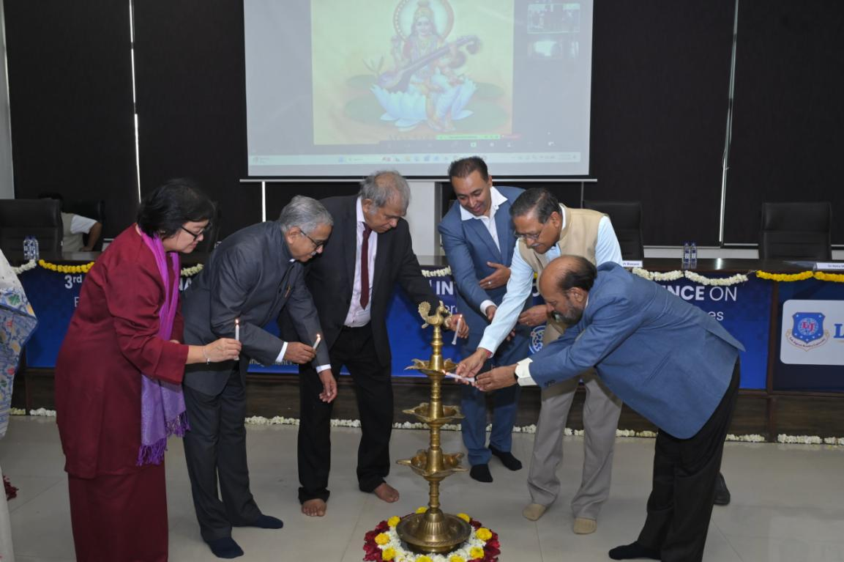
The Chief Guest, Prof. Bharat Bhasker, Director, Indian Institute of Management Ahmedabad, delivered the Inaugural Address. He traced the historical evolution of management thought, highlighting how major technological disruptions have continuously reshaped organizational structures and business practices. He emphasized that the contemporary global economy stands at a critical inflection point driven by artificial intelligence and intelligent systems.
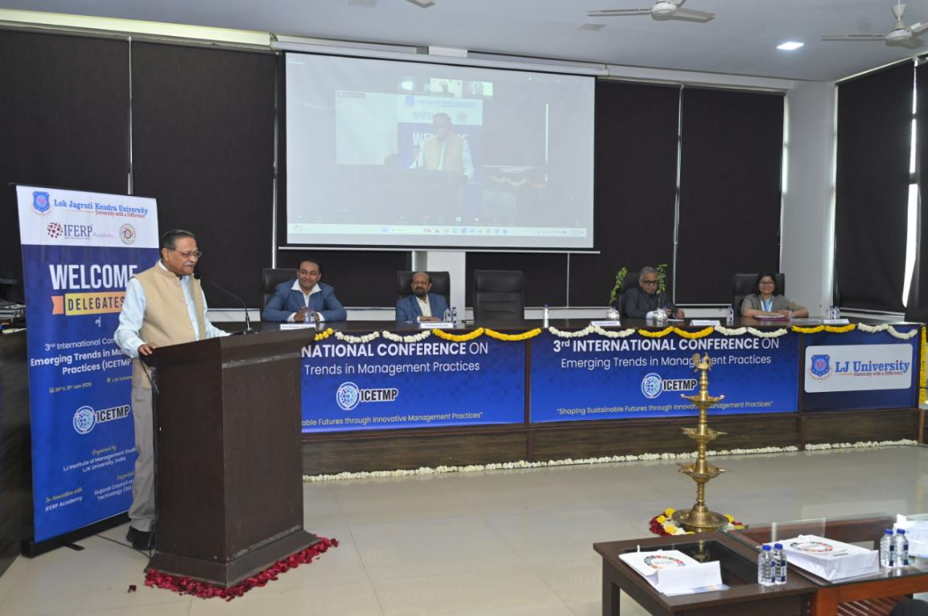
Prof. Bhasker noted that AI represents not merely incremental efficiency gains but a fundamental transformation in decision-making, value creation, and human agency. Drawing parallels with industrialization, Ford’s assembly-line revolution, and the digital transformation era, he argued that management education and practice must once again reorient to remain relevant in an increasingly automated and data-driven world. He underscored the importance of integrating technology with human capabilities to ensure inclusive growth while advancing the Sustainable Development Goals (SDGs).
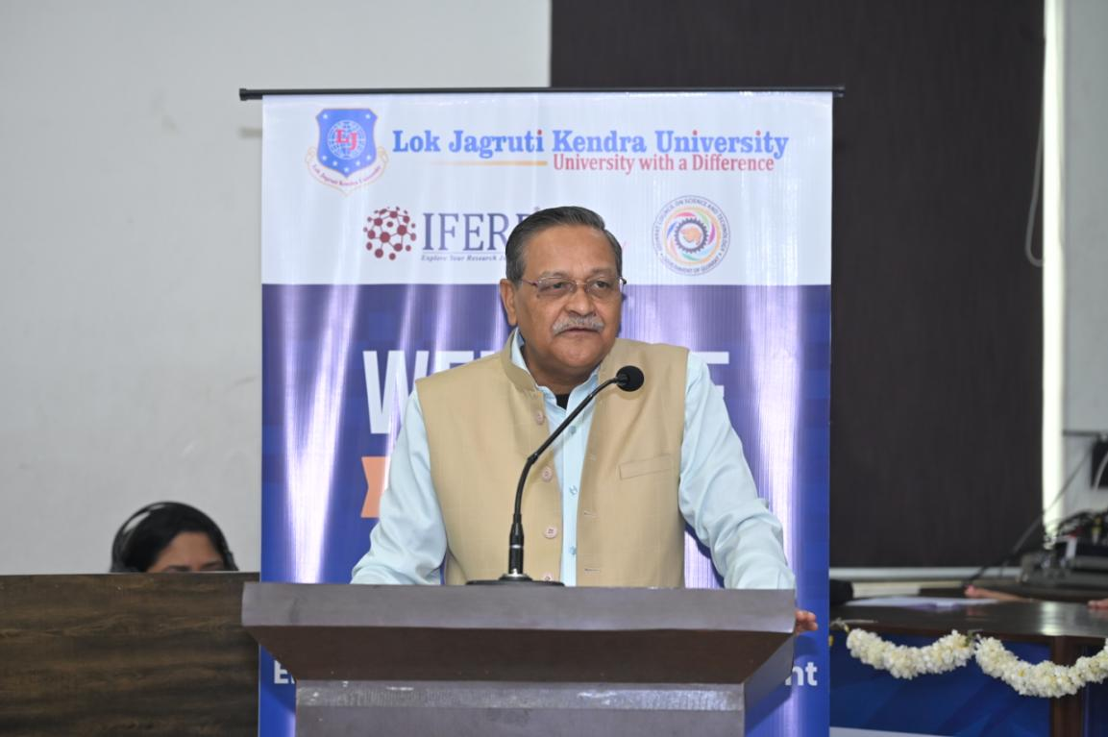
The Presidential Address was delivered by Prof. Dinesh Awasthi, Hon’ble Vice Chancellor, LJK University. He reflected on the rapid pace of technological change and its implications for employment structures and socio-economic inequality. While AI is generating high-skilled employment opportunities, it is simultaneously displacing routine and lower-skilled jobs, thereby widening disparities. He emphasized the need for collective global efforts aligned with the SDGs and advocated a shift from a shareholder-centric to a stakeholder-oriented development paradigm that balances People, Planet, and Profit.

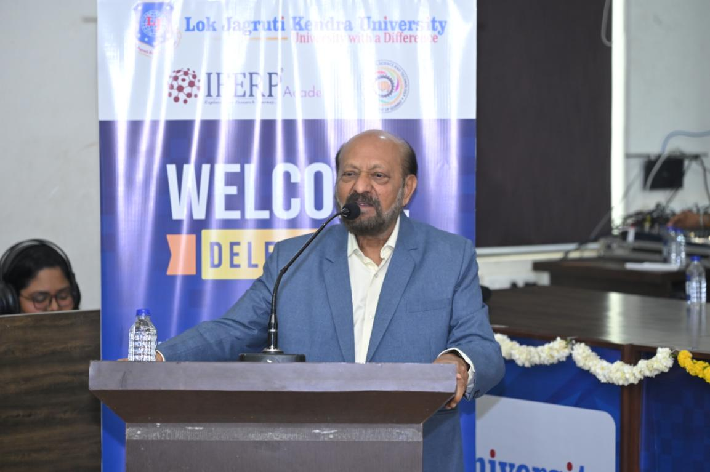

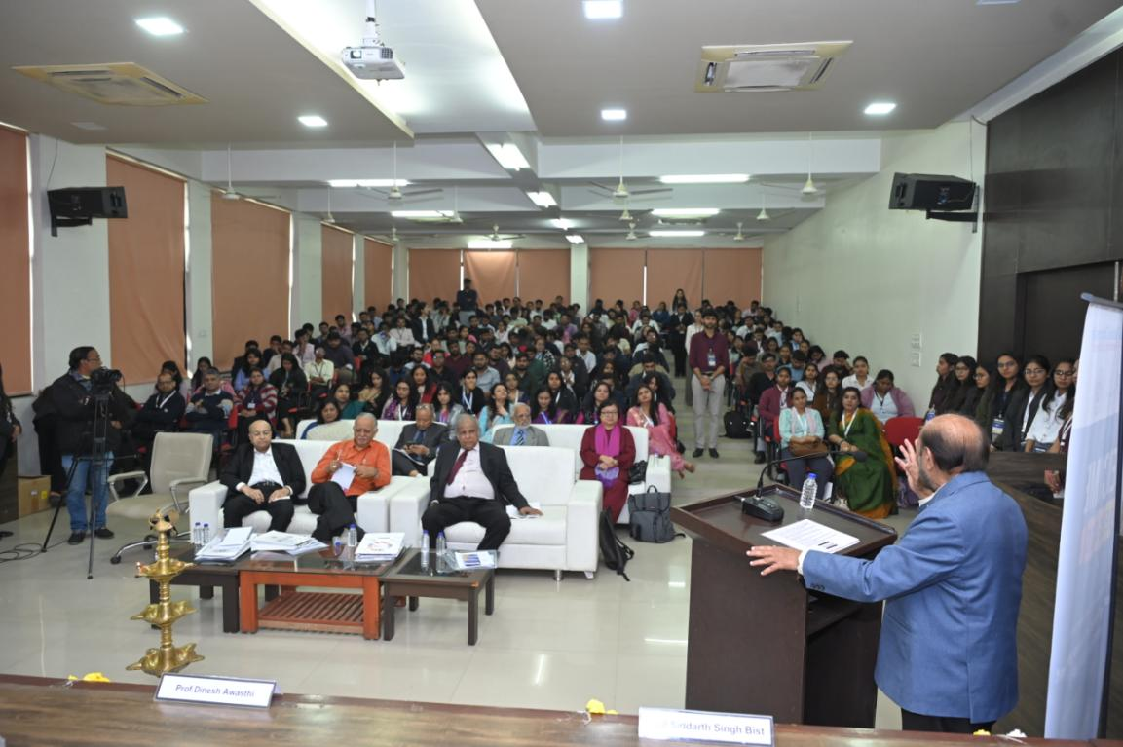
The Steering Committee Chairperson of ICETMP–2026, Prof. Rakesh Basant, Former Professor, Indian Institute of Management Ahmedabad, outlined the conference agenda and key activities planned over the two days.

Group Photo
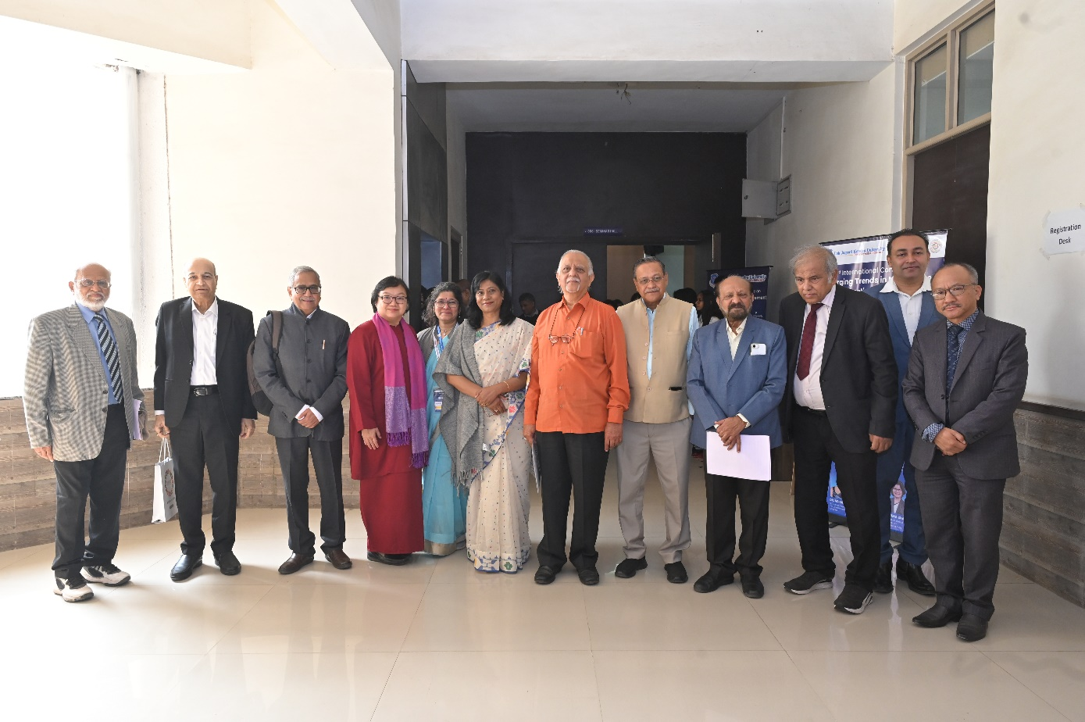
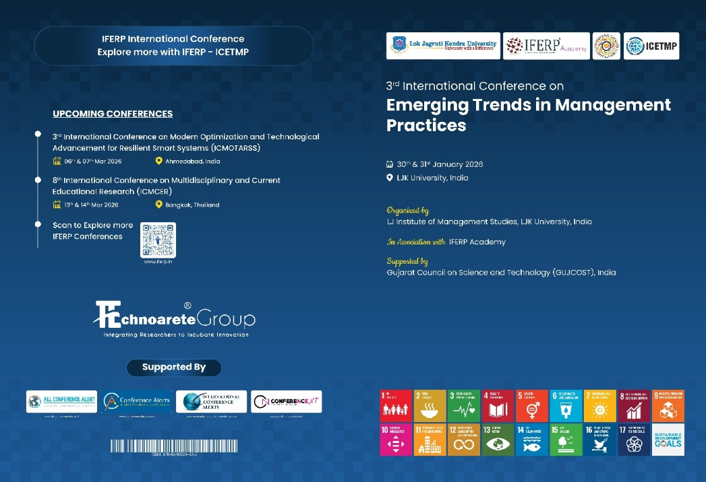
Proceedings Book: https://www.iferp.in/past-conference/icetmp-2026.php

Mementos Ceremony
The conference speakers, chief guests, & session chairs were awarded with Mementos.
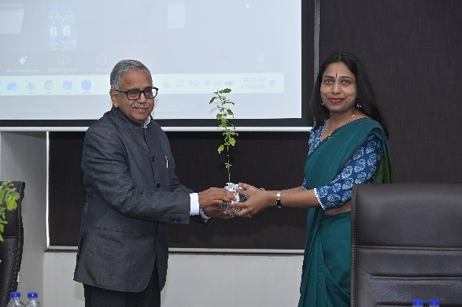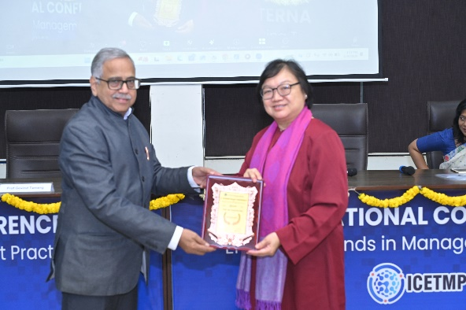
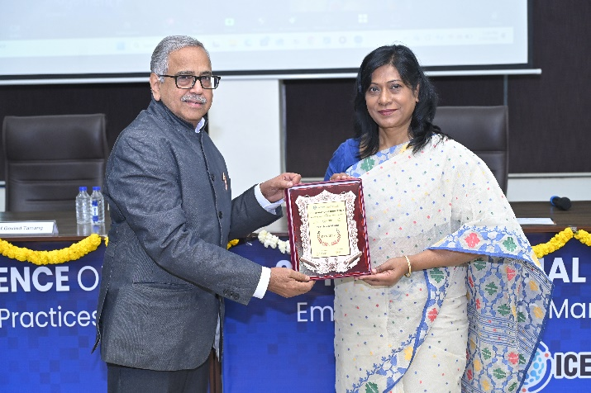

Award Ceremony – Best Presentation Awards
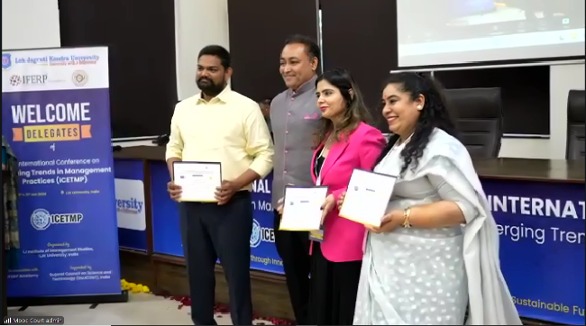 | 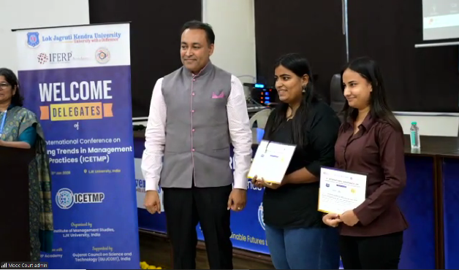

🏆 Best Paper Award Winners:
First Prize
Authors: Apurva Mehta, Dr. Ranjana Dureja, and Jatin Rajput
Institute: LJ Institute of Management Studies, LJK University
Paper Title: Workplace Happiness for Sustainable Development: A PERMA Model Perspective on Productivity and SDG Integration
Second Prize
Author: Anubha Shekhar Sinha
Institute: Indian Institute of Management Kozhikode
Paper Title: Beyond ESG Metrics: Interpreting Responsibility and Accountability in Financial Institutions

🏆 Best Poster Award Winners:
First Prize
Monika Lakhnai and Nandni Joshi
Pandit Deendayal Energy University
Poster Title: Management Effectiveness of Pradhan Mantri Awas Yojana (PMAY) in Advancing SDGs: Evidence from Indian States (2015–2020)
Second Prize
Thakkar Priyanshu, Agravat Darshan, and Budhbhatti Rudra
LJ Institute of Management Studies
Poster Title: Understanding Generation Z: Marketing Preferences, Trends & Digital Platforms
Third Prize
Jadav Prowess Ashokbhai
LJ Institute of Management Studies
Poster Title: A Study of Generation Z’s Perception of the Use of Biofuel in the Indian Economy: Evidence from Ahmedabad City

Valedictory Function
Conference - Conclusion Summary
Key Highlights:
ICETMP-2026 featured inspiring keynote addresses, thought-provoking panel discussions, and diverse technical sessions aligned with its sustainability-focused theme. The event fostered strong interdisciplinary engagement and global participation.
Research Presentations:
Participants presented innovative studies across education, engineering, and technology, showcasing practical solutions and future-oriented research. The sessions encouraged critical dialogue and knowledge exchange.
Networking Opportunities:
Delegates connected through interactive forums, collaborative meetings, and informal discussions, building international partnerships and exploring future research and industry collaborations.
Achievements and Outcomes:
The conference strengthened academic networks, promoted collaborative projects, and facilitated the dissemination of high-impact research. Several initiatives for joint studies and publications were initiated.
Closing Remarks:
The organizing committee expressed gratitude to all contributors and reaffirmed its commitment to advancing multidisciplinary scholarship. ICETMP-2026 concluded with optimism and anticipation for future editions.

Vote of Thanks
ICETMP–2026 successfully fostered interdisciplinary dialogue on sustainable management practices in the context of rapid technological transformation. Through keynote lectures, panel discussions, and research presentations, the conference reinforced the critical role of management scholarship and practice in advancing the Sustainable Development Goals.
The Valedictory Ceremony marked the successful culmination of two days of global academic engagement, collaborative reflection, and forward-looking discourse on sustainable futures.

Conference Glimpses
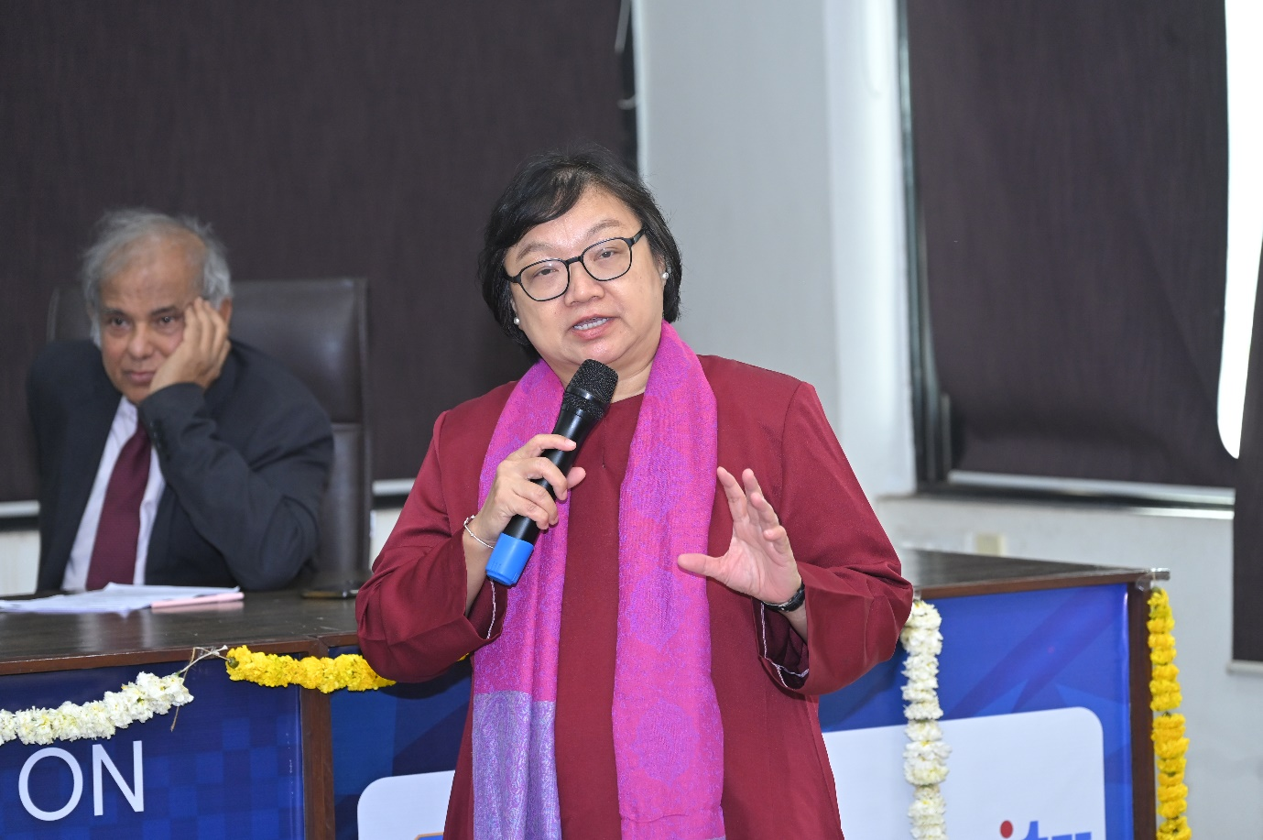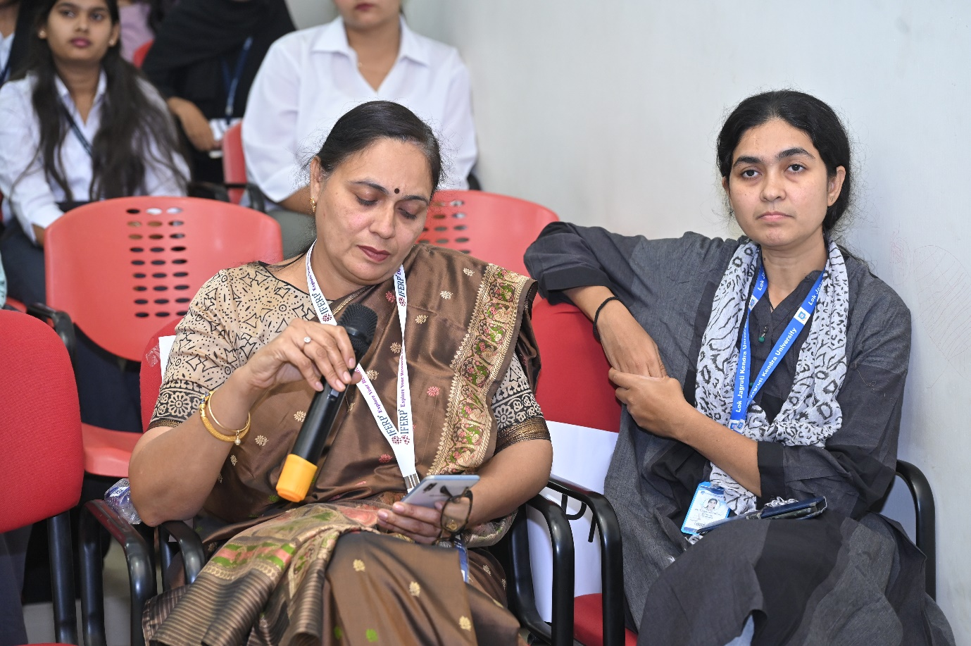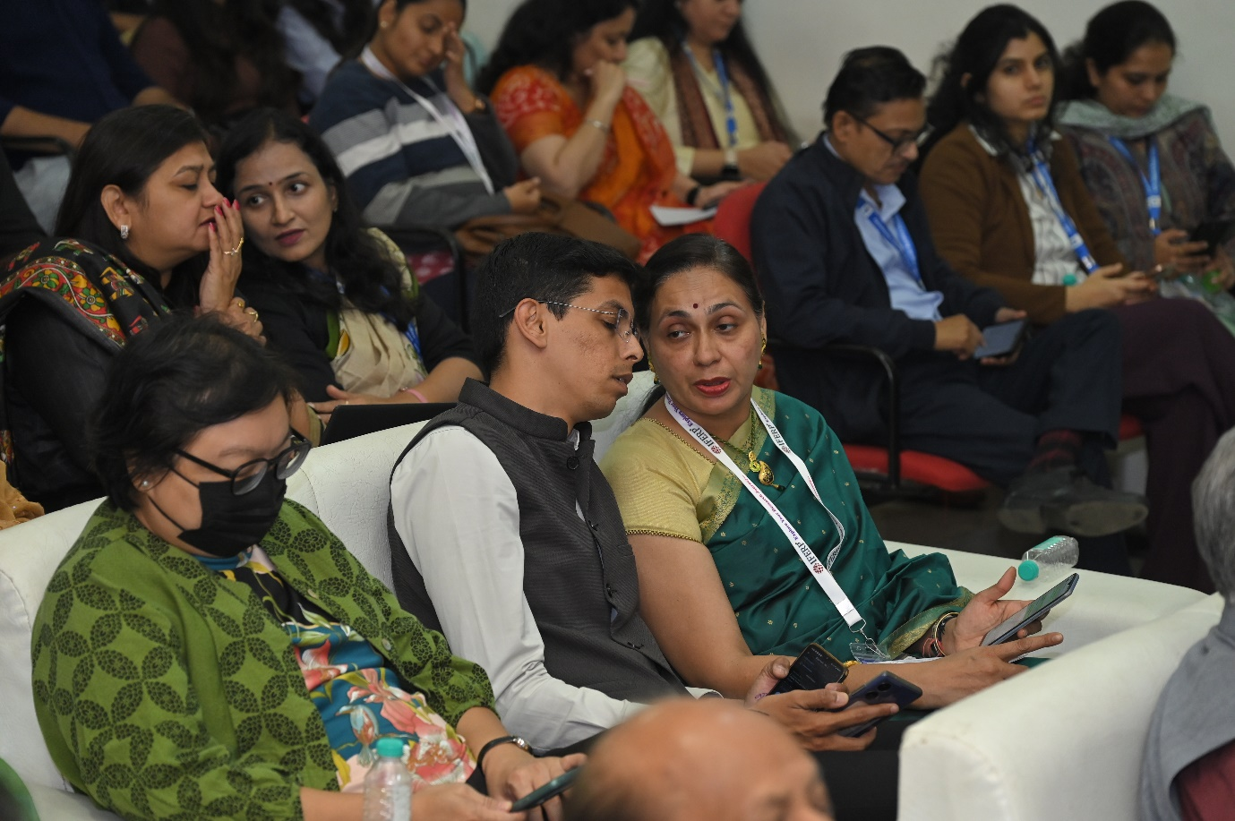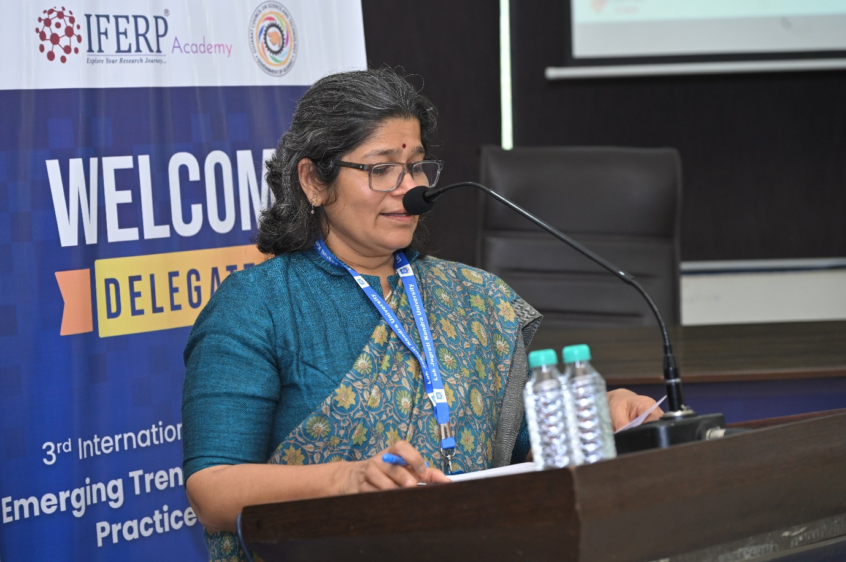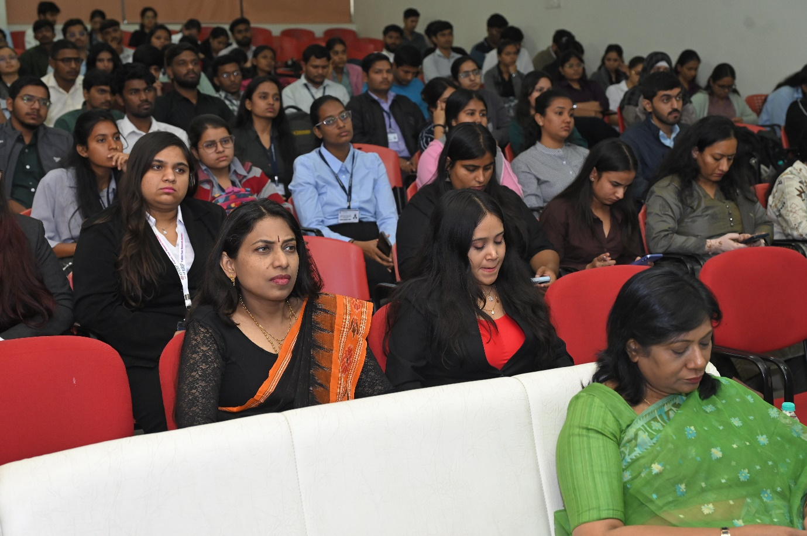

General Comments & Feedback
Overall Comments of the Participants:

- High appreciation for the quality and diversity of keynote speeches and technical sessions.

- Positive feedback on the relevance of the conference theme and multidisciplinary focus.

- Smooth organization, clear communication, and well-managed scheduling were widely noted.

- Strong satisfaction with networking opportunities and international participation.

- Delegates valued the professionalism and hospitality of the local organizing team.

- Research presentations were considered informative, innovative, and impactful.

- Panel session expressed a wide ideology of understanding and knowledge

Challenges
- Limited preparation time and lack of clearly defined guidelines from the client side resulted in increased operational pressure during the conference organization process.

- Frequent revisions and continuous changes, without defined limits or structured timelines, led to delays in previously set deadlines and impacted the progress of subsequent tasks.

- Last-minute requirements and operational constraints created additional pressure, which at times led to tension and communication challenges between the organizing team and the respective university point of contact.

