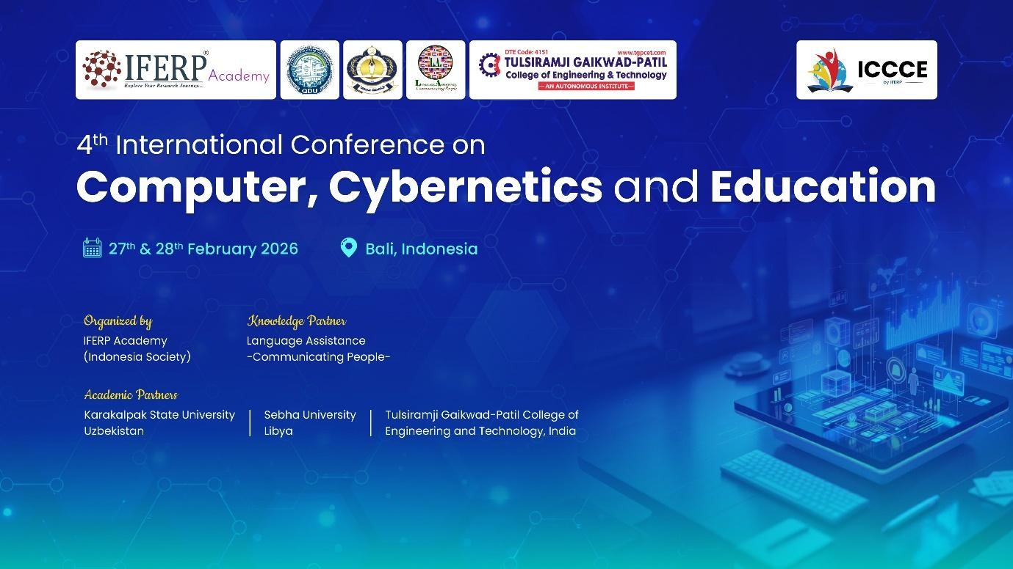
4th International Conference on Computer, Cybernetics and Education
(ICCCE- 2026)
Organized by IFERP Academy – Indonesia Society
In Association with
Karakalpak State University, Tulsiramji Gaikwad-Patil College of Engineering and Technology, Sebha University, Libya and IFERP Academy - Indonesia Society.

Post Conference Report
4th ICCCE– 2026, Contributed to Following SDGs
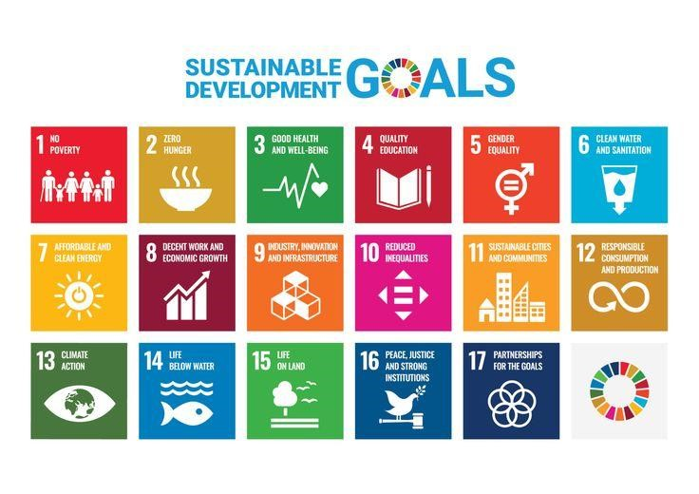

MD & Founder
IFERP, Technoarete Group.

Foreword
It gives me great pleasure to share with you the outcomes and results of the 4th
International Conference on Computer, Cybernetics and Education (ICCCE2026), which was held on February 27th & 28th, 2026. More than 300 people attended the event in person, and more than 500 people watched the live stream online. We were able to actively engage and reach out to a wider spectrum of research communities.

The 4th International Conference on Computer, Cybernetics and Education (ICCCE-2026) provided a vibrant platform that brings together scholars, educators, and researchers from a variety of disciplines. It serves as a hub for exchanging innovative research and ideas in the fields of computer science, cybernetics, artificial intelligence, educational technologies, and related interdisciplinary areas. The conference encourages critical and creative thinking while promoting collaboration and knowledge sharing among global research communities.

We are grateful for the support of many universities and research institutes whose contributions were vital to the success of this conference. We extend our sincere gratitude and highest respect to the professors who played an important role in the review process, providing valuable feedback and suggestions to authors to improve their work. We also extend our appreciation to the external reviewers for their additional support in the review process and to the authors for contributing their valuable research to the 4th International Conference on Computer, Cybernetics and Education (ICCCE-2026).

Mr. Siddth Kumar Chhajer
MD & Founder
IFERP, Technoarete Group.

Table of Contents 1. Conference Summary
1.1 Conference Overview
1.2 Conference Theme
1.3 Objectives & Scope of the Conference
2. Guest of Honor, Keynote Speakers, Session & Session Chairs , Pannel Discussions Speakers 3. Welcoming & Introduction 4. Welcome Speeches
4.1 Welcome Speech by Special Guest : Dr. Premanand Naktode

5. Keynote Speeches
5.1 Keynote Speech by Mr. Juan Intan Kanggrawan
5.2 Keynote Speech by Prof. Dr. I Nengah Subadra
5.3 Keynote Speech by Prof. Dr. Akbar Ahmad Prof. Dr. Akbar Ahmad
5.6 Keynote Speech by Prof. Dr. Swapnili Karmore

6. Pannel Discussions
- Group Photo
- Inaugural Programme
- Conference Proceedings Book Release
- Momento Ceremony
- Technical Presentation Sessions

  - Technical Presentation Session 1 A
    - Mr. Juan Intan Kanggrawan
    - Prof. Dr. I Nengah Subadra

- Technical Presentation Sessions 13.1 Technical Presentation Session 2 A

    - Prof. Dr. Akbar Ahmad
    - Prof . Dr. Swapnili Karmore

- Award Ceremony - Best Paper Presentation Awards
- Valedictory Function
- Vote of Thanks
- Conference Glimpses
- General Comments & Feedbacks

1. Conference Summary

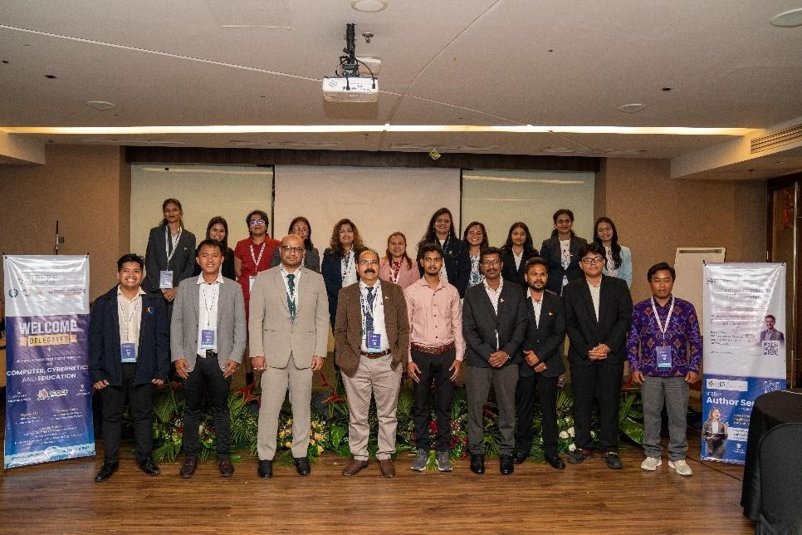

4th International Conference on Computer, Cybernetics and Education (ICCCE- 2026) Organized by IFERP Academy – Indonesia Society In Association with
Karakalpak State University, Tulsi Ramji Gaikwad-Patil College of Engineering and Technology,Sebha University, Libya and IFERP Academy - Indonesia Society.

No. of Organizing Committee Members :
No. of Editors/Reviewers :
No. of Speakers : 15
No. of Abstracts Received : 59
No. of Participants Registered : 59
No. of Attendees : 52

1.1 Conference Overview
The International Conference on Computer, Cybernetics and Education (ICCCE) served as a dynamic platform where innovative ideas, research advancements, and interdisciplinary collaboration converged to address emerging challenges in technology, cybernetics, and education. The conference brought together academics, researchers, industry professionals, policymakers, and students from around the world to exchange knowledge, discuss emerging trends, and explore innovative solutions across these rapidly evolving fields.
At this international conference, participants shared their groundbreaking research findings, practical insights, and innovative perspectives in areas related to computer science, cybernetics, artificial intelligence, and modern educational technologies. The event created an environment that encouraged collaboration, networking, and intellectual exchange among professionals from diverse academic and industrial backgrounds.
Through meaningful discussions and knowledge sharing, the conference fostered interdisciplinary collaboration and promoted the integration of technology and education in addressing global challenges. The ICCCE conference contributed to shaping the future of digital learning, intelligent systems, and technological innovation, inspiring participants to drive positive transformation in their respective fields.

1.2 Conference Theme
The theme of the Empowering the Next Generation: Technology and Education for Achieving Global Sustainability highlights the importance of integrating advanced computing technologies, cybernetic systems, and innovative educational practices to address modern global challenges.
The conference served as a hub of ideas where developments in computer science, cybernetics, and education intersect to create innovative solutions for the digital era. It emphasized the multidisciplinary nature of technological advancement and recognized that meaningful progress often emerges through collaboration between different academic and professional domains.
The theme reflects the conference's commitment to fostering innovation, collaboration, and knowledge exchange across diverse disciplines. Participants were encouraged to explore emerging technologies, share cutting-edge research, and discuss strategies that contribute to technological development, digital transformation, and improved educational systems worldwide.

1.3 Objectives & Scope of the Conference
The International Conference on Computer, Cybernetics and Education (ICCCE) aims to bring together academics, researchers, industry professionals, and students from diverse backgrounds to discuss advancements, challenges, and future trends in computer science, cybernetics, and education.

Key Objectives
- Promote Knowledge Exchange: Facilitate interaction among researchers, educators, and industry professionals to share research findings and technological innovations.
- Encourage Research Collaboration: Provide opportunities for interdisciplinary collaboration and strengthen international research networks.
- Address Emerging Technological Challenges: Discuss current issues and solutions related to computing technologies, cybernetic systems, and digital education.
- Support Innovation in Technology and Education: Highlight advancements in artificial intelligence, cybernetics, machine learning, and technology-enabled learning systems.
- Enhance Professional Development: Provide opportunities for participants to improve their research, technical, and academic skills through presentations and discussions.

Scope of the Conference
The conference encompasses a broad range of disciplines including, but not limited to:
- Computer Science: Topics such as artificial intelligence, data science, cybersecurity, software engineering, cloud computing, and information systems.
- Cybernetics: Research related to intelligent systems, robotics, automation, control systems, and human–machine interaction.
- Educational Technology: Innovations in digital learning, online education platforms, smart classrooms, and technology-enhanced learning environments.
- Interdisciplinary Research: Studies that integrate computing technologies with educational practices to develop innovative solutions for global challenges.

2. Guest of Honor, Keynote Speakers, Workshop Speakers & Session Chairs

The International Conference on Computer, Cybernetics and Education (ICCCE) featured distinguished Guest of Honor, Keynote Speakers, Pannel Discussion, and Session Chairs from leading universities, research institutions, and industries worldwide.

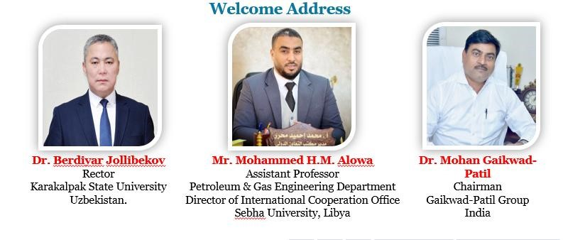
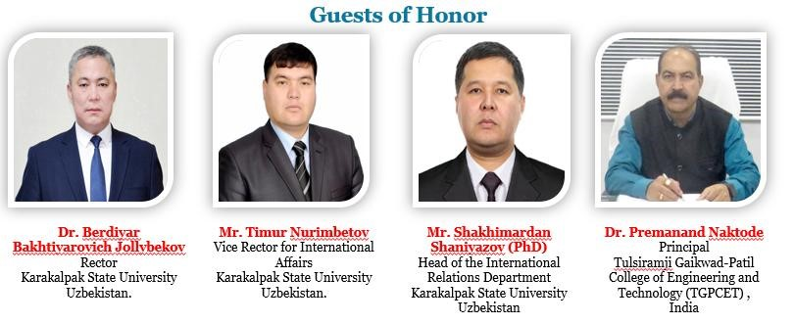

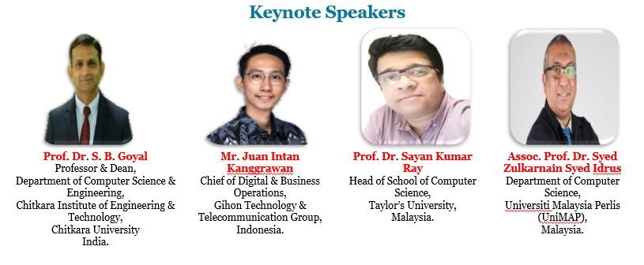

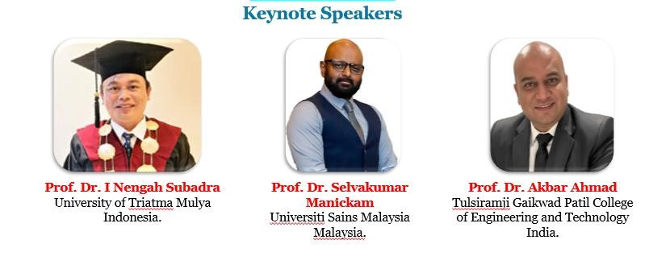

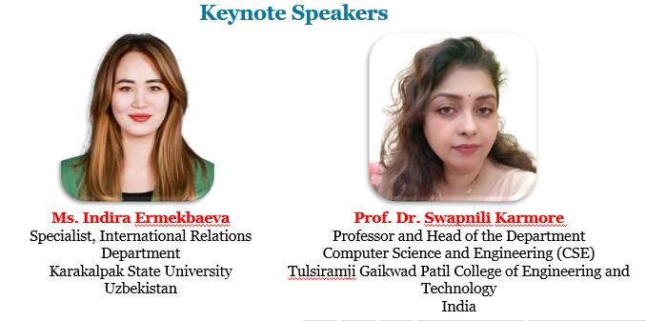

Plenary Keynote Speakers

 | 
Pravin Nagare  Sr. Software Engineer,  Roku Inc., California,  USA | Vamshidhar Reddy Vemula  Lead Software Engineer Wellsfargo  USA

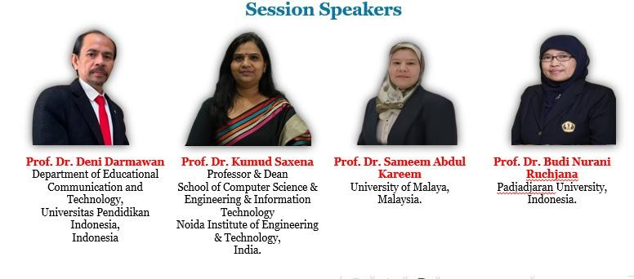

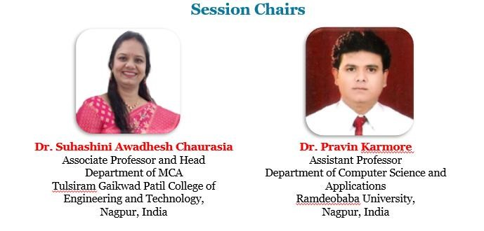

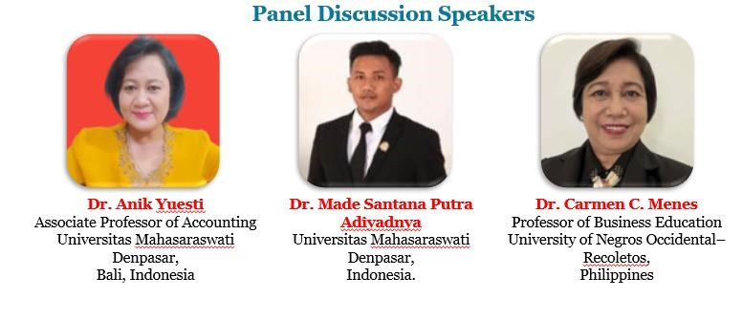

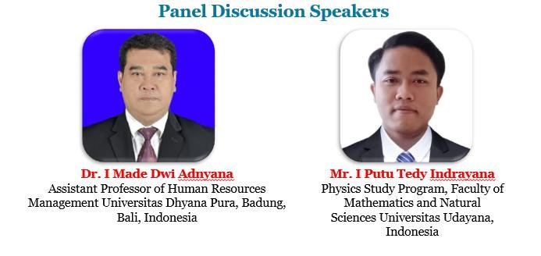

3. Welcoming & Introduction
Welcome to the International Conference on Computer, Cybernetics and Education (ICCCE), a platform that brings together researchers, academics, industry professionals, and students to share knowledge and explore recent advancements in computer science, cybernetics, and education.
This conference aims to promote collaboration, innovation, and the exchange of ideas across these interdisciplinary fields. Through keynote sessions, technical presentations, and discussions, participants will gain valuable insights into emerging technologies and research trends. We extend our sincere appreciation to our conference chairs, keynote speakers, organizing committee members, and volunteers for their dedication in making this conference a successful and enriching experience for all participants.

4. Welcome Speeches Dr. Premanand Nakoda
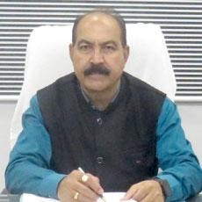

Dr. Premanand Naktode
Principal
Tulsiramji Gaikwad-Patil College of Engineering and Technology (TGPCET) ,
India

5. 1 Speech by Conference chair - Dr. Agung Triayudi


Dr. Agung Triayudi Dean
Computer Science
Universitas Nasional (UNAS) Indonesia.

6. Panel Discussion Title : Digital Education for Sustainable Futures: Leveraging Computer Science to Achieve the UN SDG

6.1 Dr. Anik Yuesti
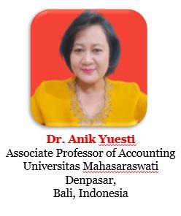

6.2 Dr. Made Santana Putra Adiyadnya
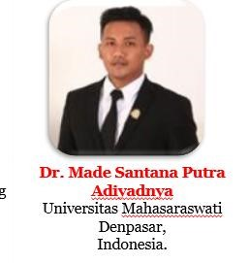

6.3 Dr. Carmen C Menes
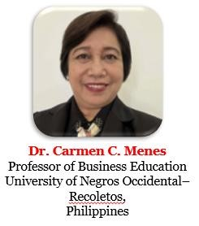

6.4 Dr. I Made Dwi Adnyana,

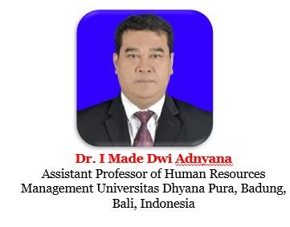
6.5 Mr. I Putu Tedy Indrayana


7. Group Photo
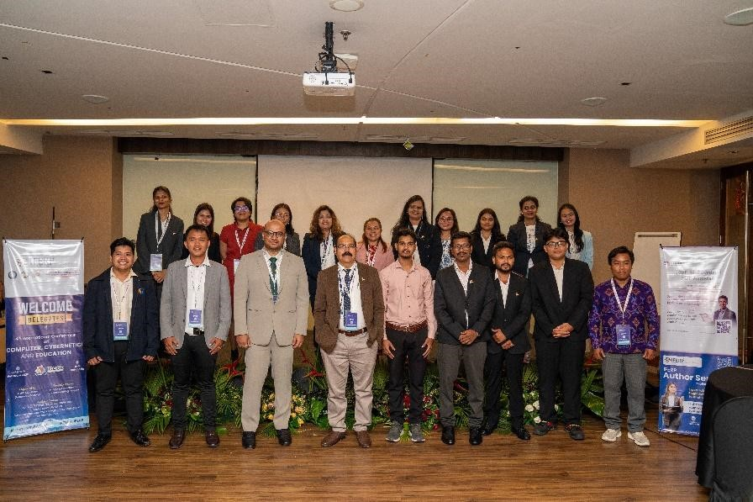

9. Inaugural Programme
The inaugural program of the 4th International Conference on Computer, Cybernetics, and Education (ICCCE - 2025), held on 27th & 28th February 2025, served as a significant opening to the conference proceedings. It set the tone for the entire event by introducing the conference theme, objectives, and distinguished participants.

The inaugural session featured keynote addresses, the release of conference proceedings, a momento presentation ceremony, and highlights of campus benefits. This session played a crucial role in welcoming and engaging participants, establishing the context for insightful discussions, and recognizing the valuable contributions of esteemed speakers and contributors.

10. Conference Proceedings Book Release
The 4th International Conference on Computer, Cybernetics, and Education (ICCCE - 2025) conference proceedings comprised a comprehensive collection of research papers presented during the conference. The proceedings serve as a valuable record of the scholarly work and discussions that took place, offering insights into current trends, innovations, and future directions in the fields of Computer Science, Cybernetics, and Education.
On behalf of the organizing committee of the 4th International Conference on Computer, Cybernetics, and Education (ICCCE - 2025), the conference proceedings were officially released.

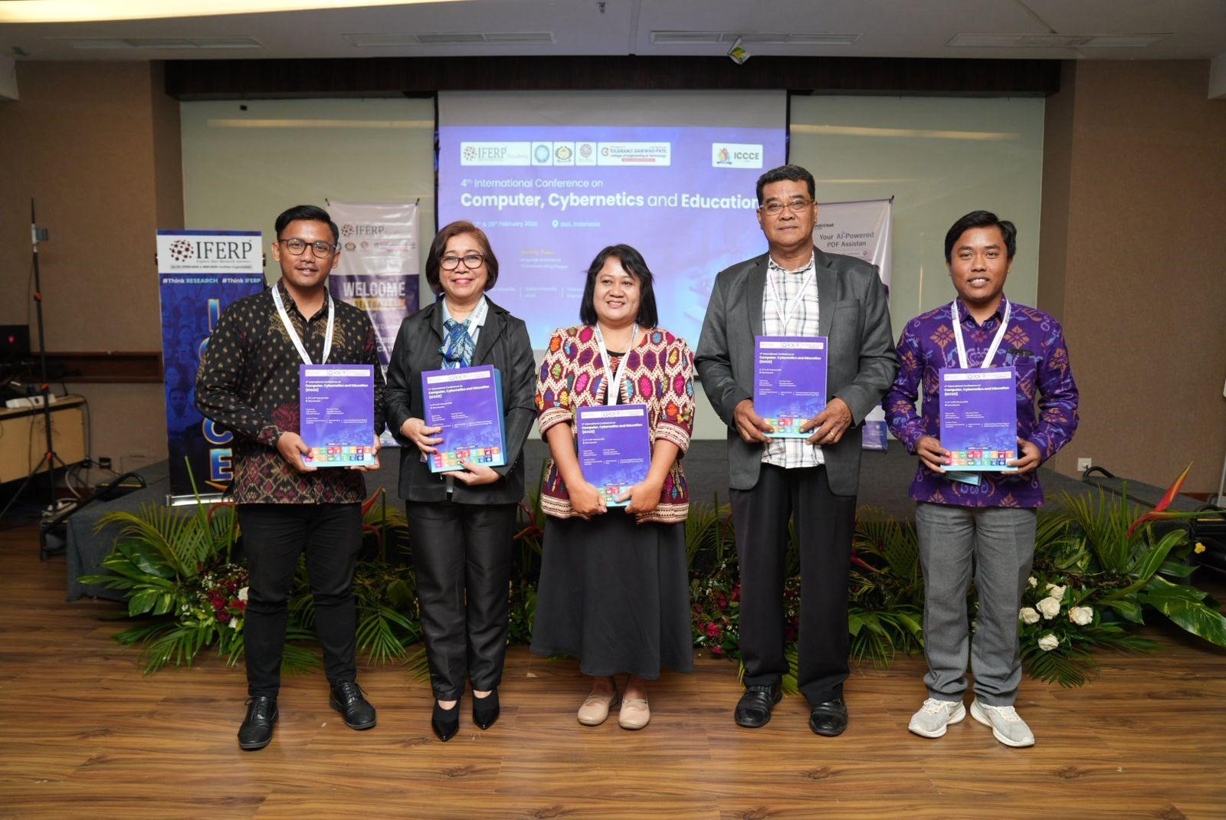

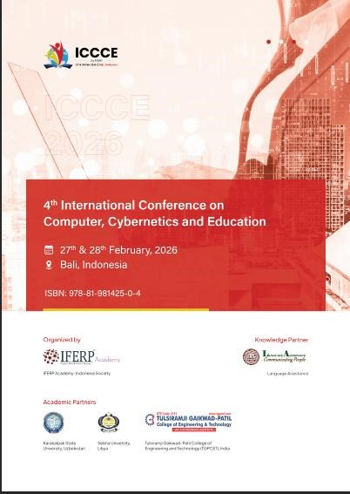

- Momento Ceremony
The conference speakers, session speakers, & session chairs were awarded with Momentos.
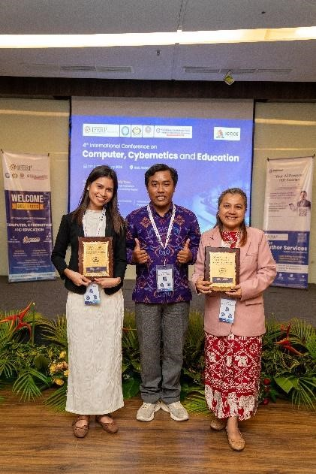

- Technical Presentation Sessions
  - Technical Presentation Session 1 A
    - Speech by Session Speaker Dr. Nishit Aman
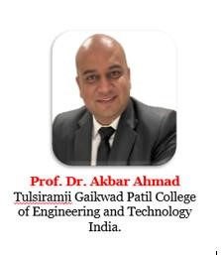

    - – 12.1.33 Total 33 Scientific Presentations were presented in the
Technical
Presentation Session 1 A
- Technical Presentation Sessions
  - Technical Presentation Session 2 A
    - Speech by Keynote Speaker Prof. Dr. Swapnili Karmore
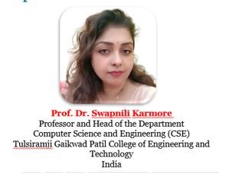

15. Award Ceremony - Best Paper Presentation Awards

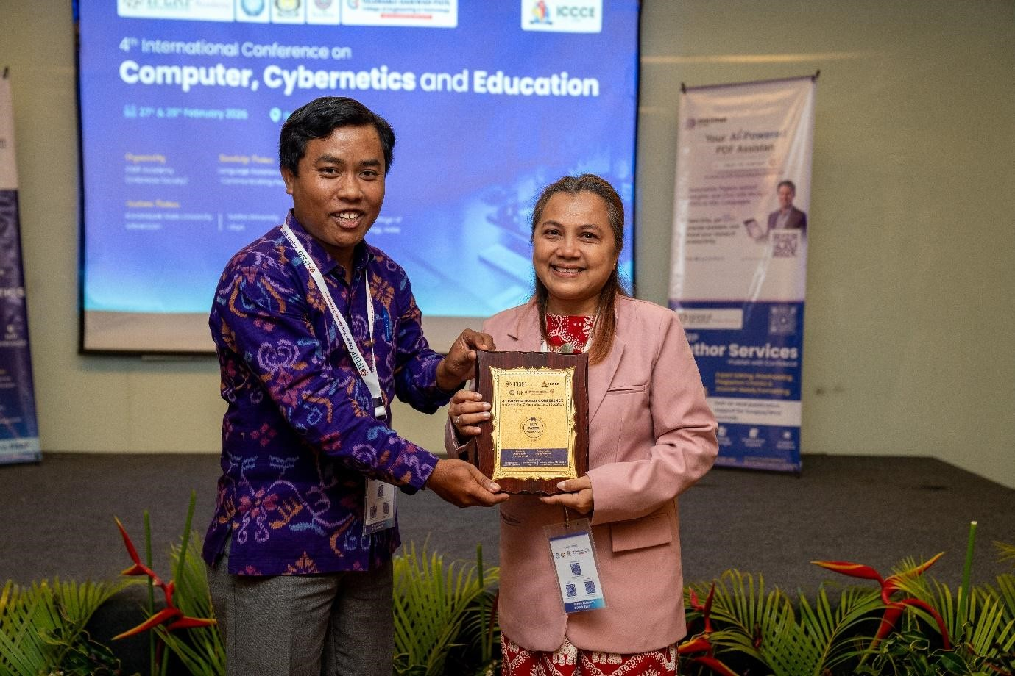

Name |  | Paper Title
 | Sharon Masula | Valuing Mangroves: Writing a  Storybook for the Promotion of Katunggan It Ibajay

16. Valedictory Function

16.1 Conference - Conclusion Summary

The 4th International Conference on Computer, Cybernetics, and Education (ICCCE - 2025), held on 27th & 28th February 2025, brought together a diverse group of researchers, academicians, industry experts, and students from across the globe. The conference successfully created a dynamic platform for sharing knowledge, exchanging ideas, and fostering innovation in the fields of Computer Science, Cybernetics, and Education.
Key Highlights:
The conference commenced with an inspiring address by the Special Guest, emphasizing the importance of interdisciplinary collaboration, innovation, and global academic excellence. The keynote speakers shared valuable insights into recent advancements and emerging trends, highlighting future opportunities in Computer Science, Cybernetics, and Education.

Research Presentations:
A significant number of research papers were presented across various technical sessions, covering a wide spectrum of topics. These presentations showcased innovative research and encouraged meaningful discussions among participants.

Networking Opportunities:
The conference provided excellent networking opportunities through both inperson and virtual sessions, enabling participants to connect with peers, experts, and potential collaborators, thereby fostering professional relationships and future partnerships.

Achievements and Outcomes:
- Several collaborative initiatives were discussed, focusing on addressing current technological and educational challenges.
- The conference proceedings, including selected research papers and keynote insights, will be published, contributing to academic and research development.
- Future conference plans were outlined to further enhance participation, knowledge sharing, and global impact.

Closing Remarks:
In the valedictory session, the organizing committee expressed heartfelt gratitude to all participants, speakers, academic partners, and sponsors for their valuable contributions. The conference was recognized as a successful platform for achieving its objectives and promoting continued collaboration and innovation.

The conference concluded on a positive note, with participants inspired and motivated to apply the knowledge gained in their respective domains and contribute to future advancements.

17. Vote of Thanks

Dear Researchers, Academicians & Students,

As we come to the close of the 4th International Conference on Computer, Cybernetics, and Education (ICCCE - 2025), it is our privilege to extend a heartfelt vote of thanks on behalf of the organizing committee.
We sincerely thank our esteemed speakers for their insightful presentations and valuable contributions, which have greatly enriched this conference. Your expertise and perspectives have inspired all participants.
We extend our deep appreciation to the organizing committee and volunteers for their dedication, meticulous planning, and continuous efforts in ensuring the smooth execution of the conference.
Our gratitude also goes to all participants and attendees. Your active involvement, engaging discussions, and enthusiasm have significantly contributed to the success of this event.
We would like to acknowledge all supporting partners, sponsors, and collaborators for their valuable support.
Finally, we thank everyone who contributed directly or indirectly to making this conference a success.

As we conclude, let us carry forward the knowledge, connections, and inspiration gained during this conference. We look forward to your continued participation in our future events.

Thank you all.

18. Conference Glimpses

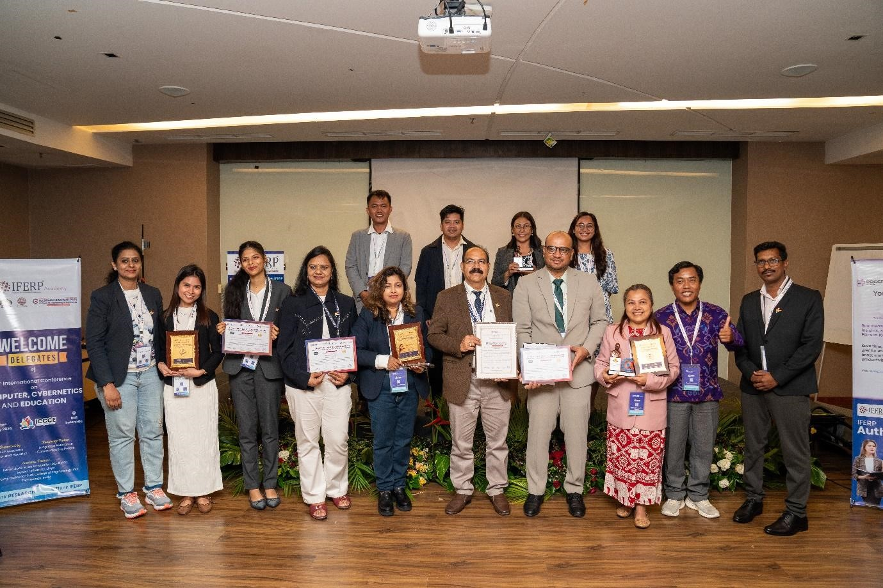

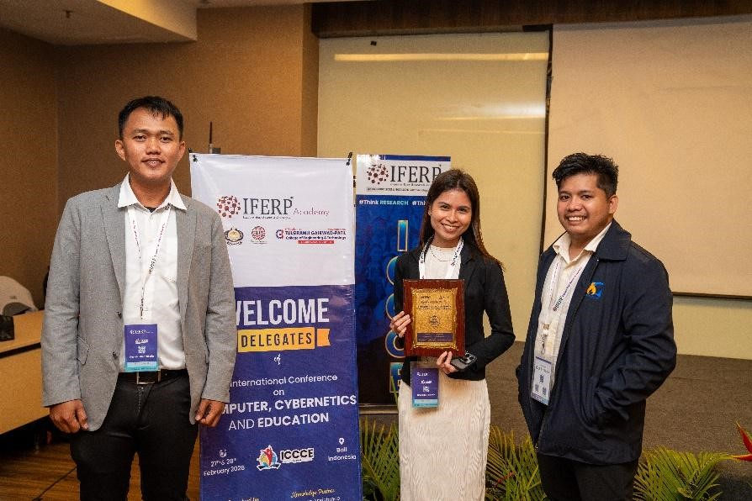

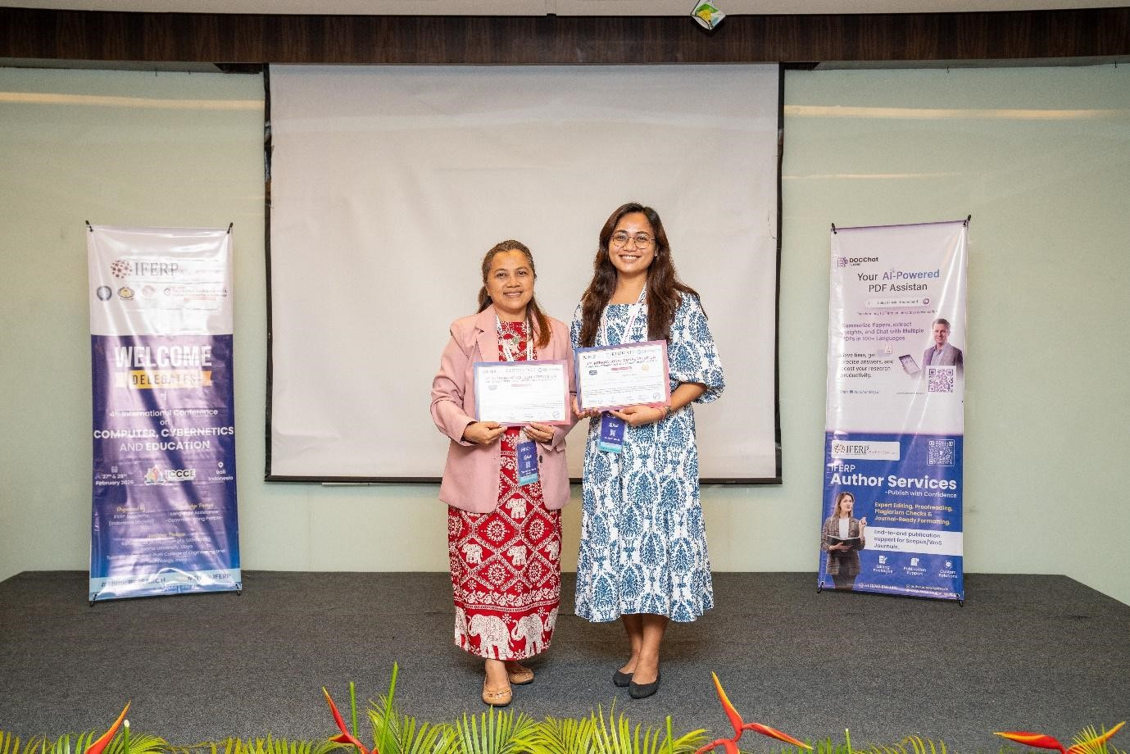

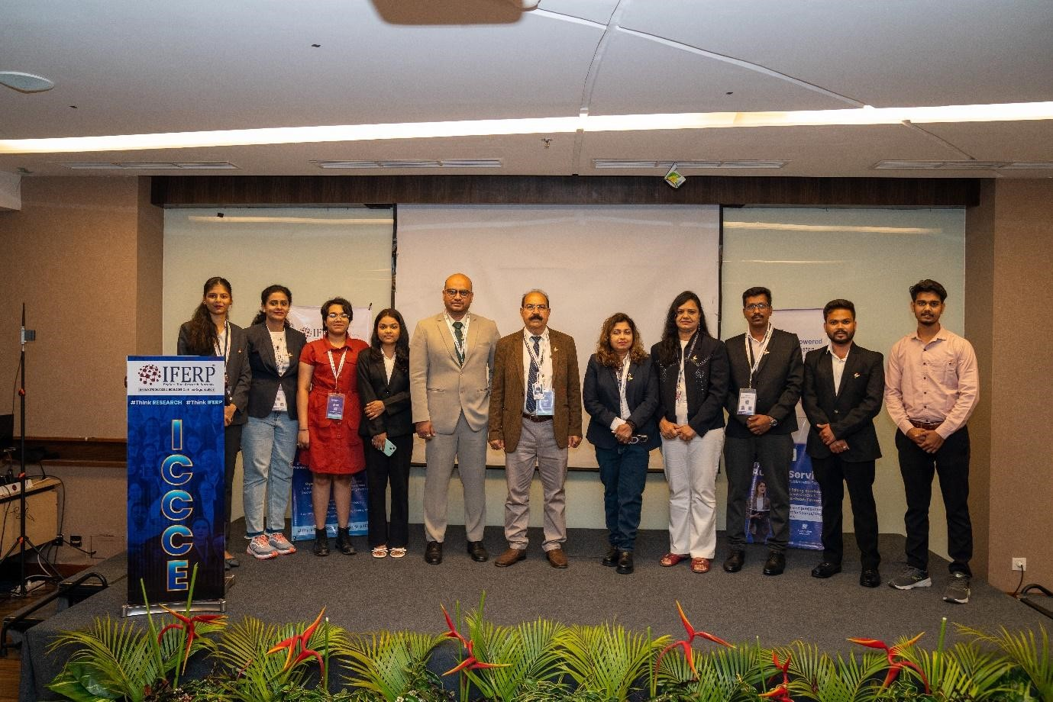

19. General Comments & Feedbacks
Overall Comments of the Participants:
- Organizing and Coordination of the conference was excellent and professional.
- Speakers were no doubt enriching.
- Overall, an excellent International Conference.
- Workshops were very interactive
- The introduction of the conference program was so effective that it distracts you from the research topic
- Keynote speakers talks were worth listening.
- International Mobility Exchange Program highlighted the conference with research lab visits.
- Issues were resolved carefully.

